Supervised Learning includes with **Features(input)** and **Label(result)**

Supervised Learning must have Label, if Label not found that would be considered as Unsupervised Learning.

**What is Supervised Machine Learning?**

In Supervised learning, you train the machine using data which is well **“Labeled”**. It means some data is already tagged with the correct answer. It can be compared to learning which takes place in the presence of a supervisor or a teacher.

**What is Unsupervised Machine Learning?**

Unsupervised learning is a machine learning technique, where you do not need to supervise the model. Instead, you need to allow the model to work on its own to discover information. It mainly deals with the unlabeled data.

**Algorithms**

**SVM** means Support vector Machine

**PCA** means Principal Component Analysis

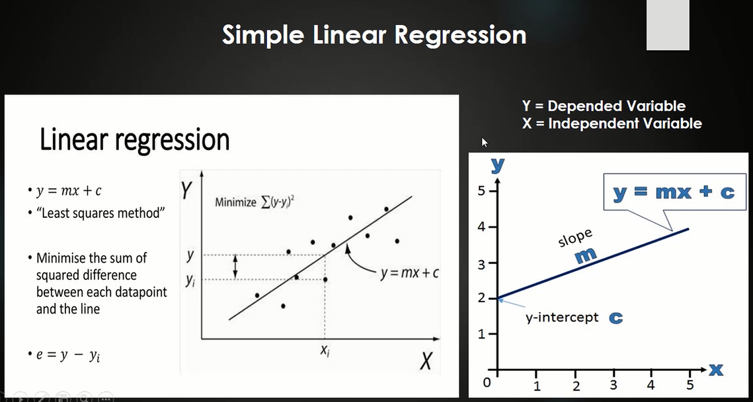

**Linear Regression:** Linear refers to a straight line, and regression refers to, predict a real value as an output. So, it’s like Linear Regression means predict a value using a straight line. If model predict value with a curve line, that would be polynomial regression.

Linear regression is a process to make relation between independent variable and dependent variable.